- Search the plurasight
https://www.pluralsight.com/
- Click on view plans
- Select for individuals
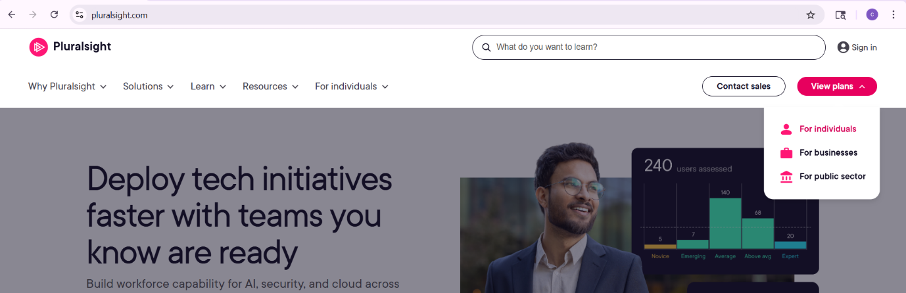
- Select cloud + plan
- Cick on buy

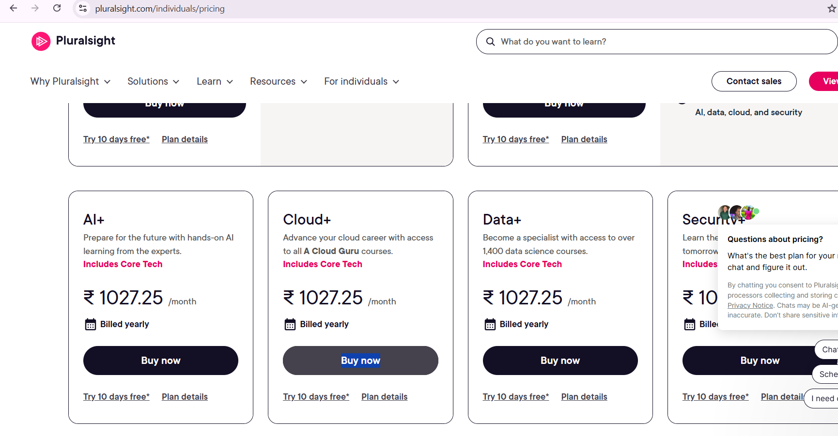
- Give the promo code and apply
- Give your account details like mail, name and all
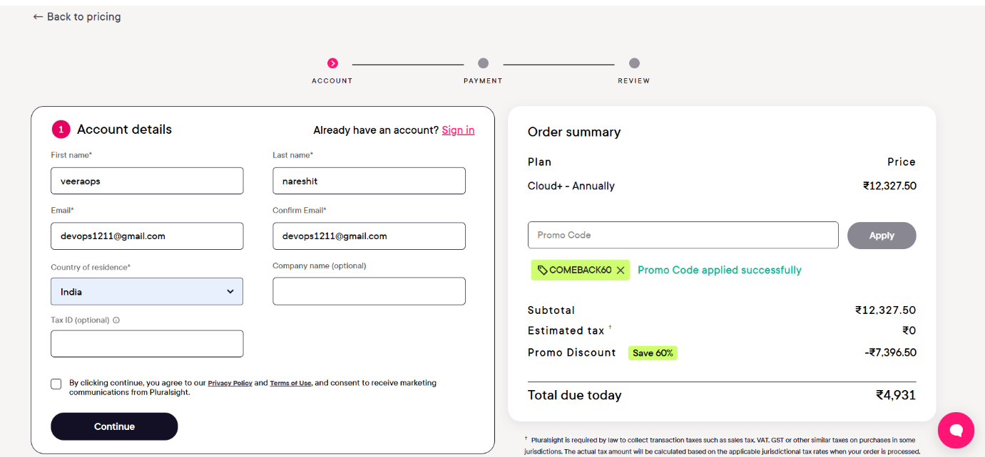
- Selct payment as card

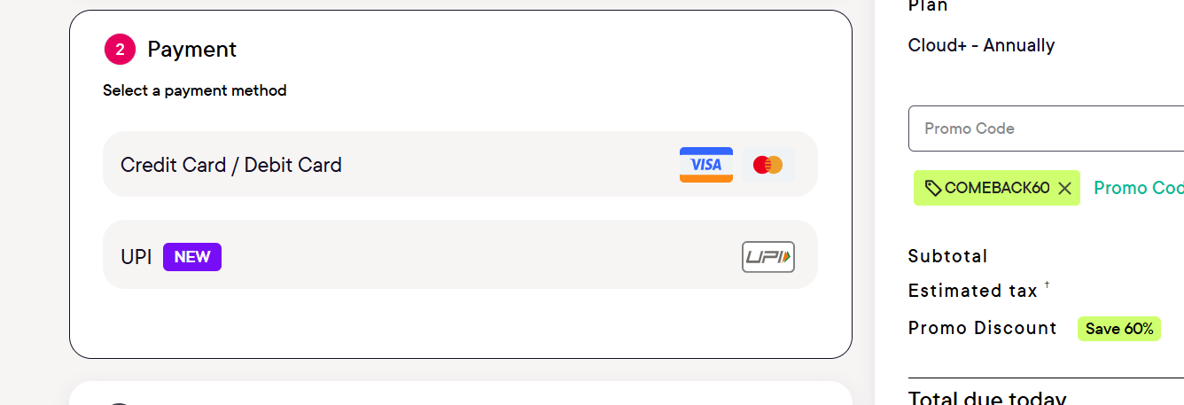
- Give your payment details
- It will debit around 5818 rupees
- Review the order and enter your otp order

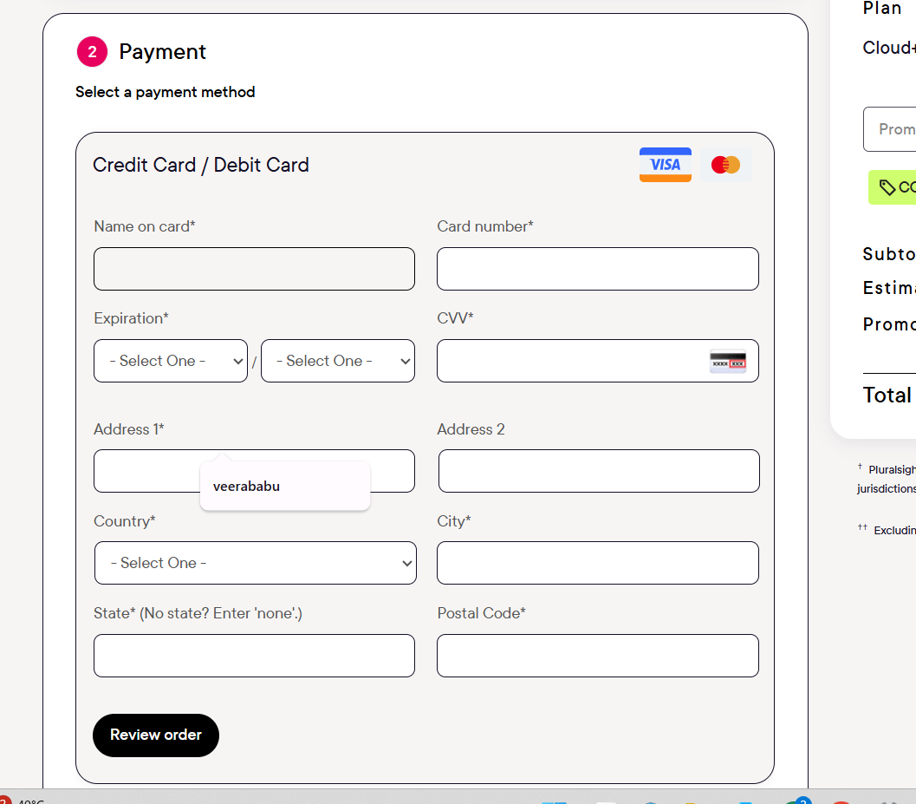
After the payment set the password for your account

